IT2035C Networking Infrastructure Management

Configuring DHCP Lab 2 Submission Form

Complete the DHCP Lab 2 and submit the following screenshots. Ensure all screenshots are viewable.
- The network diagram includes the router, three switches, a server, and four PCs. The statically assigned interfaces are annotated. Student's name, section number, and lab number are shown.
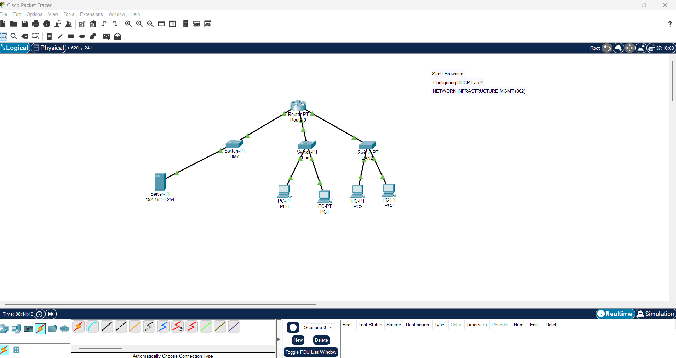

- The ‘show run’ command displays the three router interfaces with valid assigned IP and the ip helper-addresses. Hit ‘enter’ several times until the configuration is displayed.

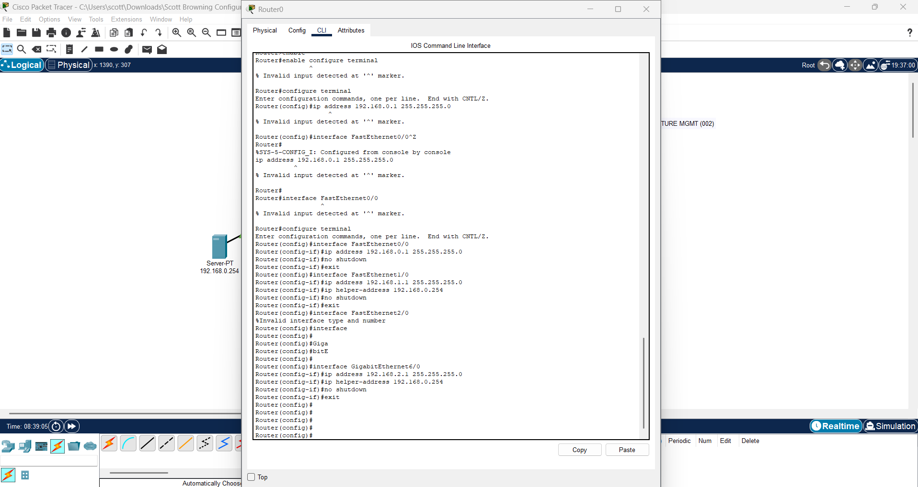
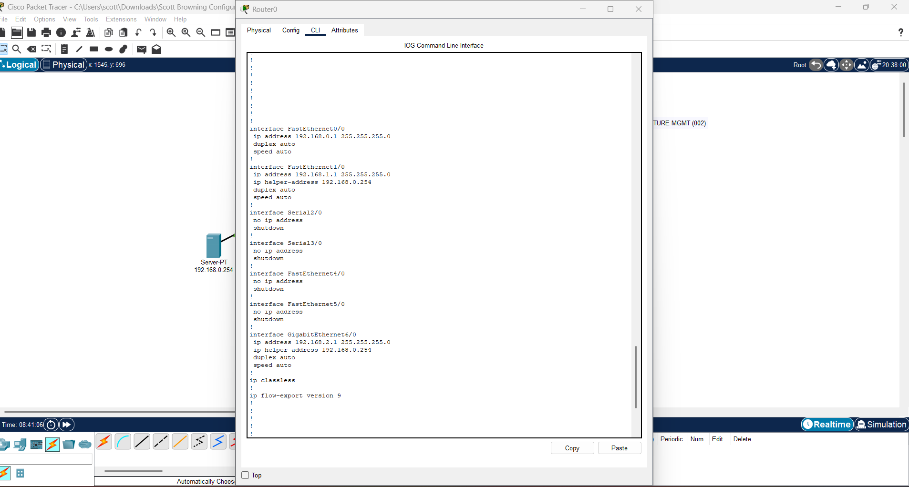
- DHCP Configuration on the PC showing the PC has been assigned a valid address, subnet mask, and default gateway through DHCP. (Desktop IP Configuration)

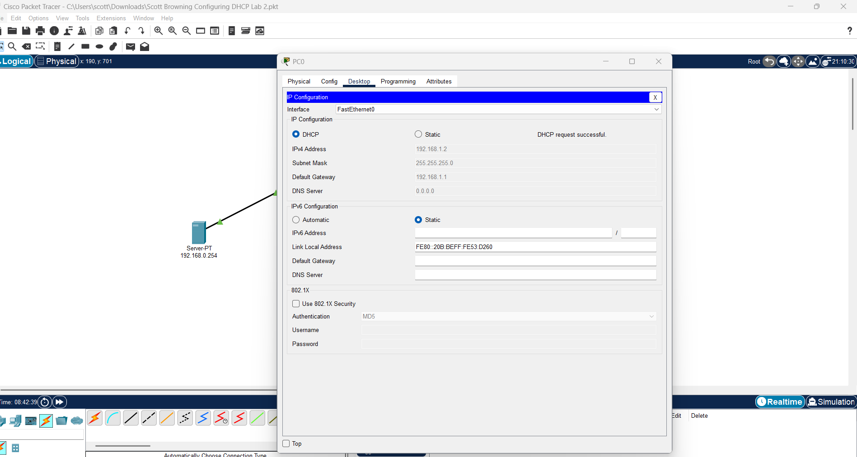
- Configuration of the DHCP pools displaying the correct range of IP addressing and default gateway address for each subnet. 